Applicability

This download is an internet release which has been provided pending replication and despatch of the Cashdata 2012 product to customers.

What’s Different to the CD
The download is identical to the CD, in that it contains the same software, installation guide, installer etc.

About this download:
This download consists of one self executing zip file 2012CASHDATA.exe

Download the file to a local directory into a new folder or a subfolder (e.g. My Documents\Cashdata2012) is recommended as it is less likely to be subject to possible network issues. The file may then be copied to a memory stick device or installation commenced as per these instructions.

During the unzip process you will be asked to enter a password. This will have been sent to you via e-mail. If you have not received your password please phone Practitioner Technologies on 07 32200422.

How to install the Software

Double click on the file “2012Cashdata.exe” which will launch the “winzip” self extractor.

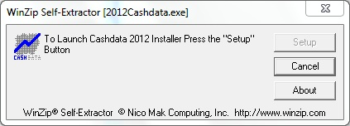

Press the “Setup” button. You will then be requested to key the password provided to you.

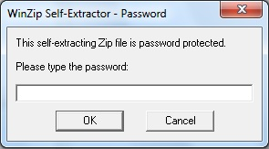

The extractor will then advise it is unzipping the software to a temporary folder and will perform the unzipping.

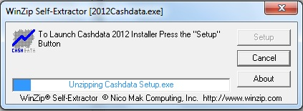

After unzipping the extractor will launch the Cashdata 2012 Installer menu.

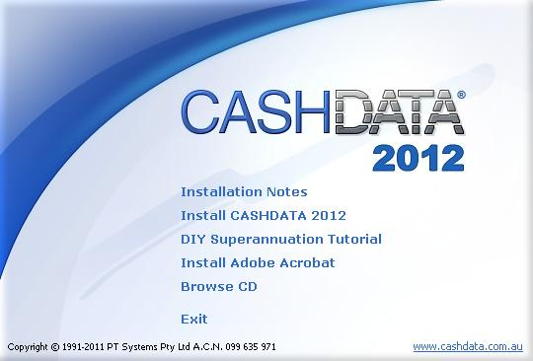

Install Cashdata 2012 by selecting the second menu item (Install Cashdata 2012) in accordance with the installation Notes (First Menu item).

